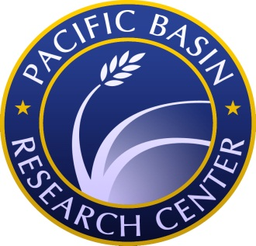
Call for Applications
John D. Montgomery Post-Doctoral Fellowship

Theme: “Religious Minorities and Minority Religions across the Pacific”

Pacific Basin Research Center
Soka University of America
2017-18 Academic Year

The Pacific Basin Research Center (PBRC) at Soka University of America, a premier Liberal Arts University in Orange County California, is pleased to announce a call for applications for the fifth annual John D. Montgomery Post-Doctoral Fellowship. The Fellowship is intended to support young scholars (not more than two years beyond defending their dissertation) whose research emphasizes humanistic development in and connections among the peoples of the Pacific Basin. This year’s theme is: “Religious Minorities and Minority Religions across the Pacific.” Applications from scholars with research interests in religious minorities (more social scientific research) or with the practices and beliefs of minority religions (grounded more in the humanities), are welcome. The geographical focus is open to scholars studying the countries of the Pacific Basin, widely defined, with priority given to those whose research connect different parts of the Pacific.

The successful applicant will receive a stipend of $50,000. The Fellow will be expected to teach one course in each of the fall and spring semesters (a 1-1 teaching load), consisting of an Introduction to World Religions (REL 104) in the Fall and a special topics course related to their research in the Spring. The successful candidate is expected to contribute to the PBRC by organizing talks, connecting to students, and conducting independent research. Additionally, the post-doctoral scholar must produce a PBRC ‘Policy Brief’ on their area of interest.

Soka University of America is located in Aliso Viejo, southern Orange County. Opening its breathtaking campus in 2001, SUA has quickly joined the ranks of some of the world’s best liberal arts campuses. The 2015 US News and World Report College Rankings placed Soka in the top fifty liberal arts institutions, placing first for faculty resources and foreign students, and fourth for best value. Boasting an average class size of 13 students, a 1:8 student to teacher ratio, and a diverse student body, SUA is committed to helping students become global citizens.

Interested candidates should send a cover letter, curriculum vitae, sample syllabus, and two letters of reference to Soka University of America’s Human Resources (jobs@soka.edu) by April 30, 2017.
If hired, you must be able to show proof of your legal right to work in the United States of America.
Employment is contingent on the completion of a successful background check.

If you have any questions, please contact PBRC Program Coordinator Kayo Yoshikawa (kayoshikawa@soka.edu).

